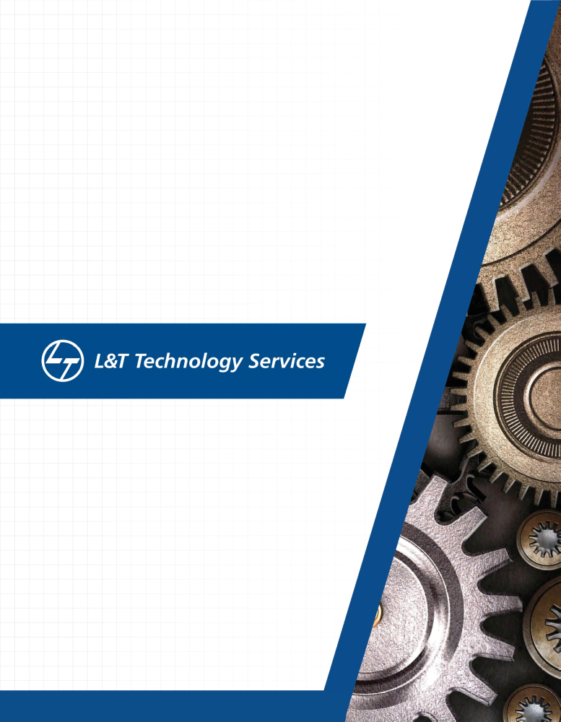./


Ver. Rel. No. | Release Date | Prepared. By | Reviewed By | Approved By | Remarks/Revision Details
1 | 01/32/2021 | Adharsha Mohan R
2
3
Document History

Activity 1: Introduction to Architecture and Design

Type of Activity: individual
Goal of Activity: Familiarisation of linux OS architecture
Topics covered: Linux OS Architecture, GCC &Build process, Utilities, Static and Dynamic libraries, Makefile creation
Learning Outcomes: Performed different functions along with test code and Makefile. Link the static and shared libraries with test code.
Challenges :Difficulty in static and dynamic makefile creation
Learning Resources:
https://web.microsoftstream.com/video/5cc492de-e71c-4c15-98ff-53727580a5b6
https://web.microsoftstream.com/video/ab1d8a45-bfb2-4187-9eda-cd83d9c31f5b
https://web.microsoftstream.com/video/9e33e60e-91e3-4b6f-ac23-937e83897e86
https://www3.ntu.edu.sg/home/ehchua/programming/cpp/gcc_make.html
References:

Activity 2: System calls, Processes

Type of Activity: Individual
Goal of Activity: Perform activities using system calls, process.
Topics covered: Linux OS Architecture, System call, Process life cycle, Scheduling, Interrupts, Context switching
Learning Outcomes: Performed different functions using system call and process.
Challenges : Difficulty in learning linux commands.

Learning Resources:
https://linuxhint.com/linux-exec-system-call/
https://www.csl.mtu.edu/cs4411.ck/www/NOTES/process/fork/create.html
https://www.csl.mtu.edu/cs4411.ck/www/NOTES/process/fork/create.html
Understanding Zombie Processes!

References:

Activity 3:

Introduction to of IPC concepts.
Type of Activity: Individual
Goal of Activity: understanding the concepts of mutex and semaphores
Topics covered: POSIX- libraries, mutex, semaphores- sem-wait, sem-post
Learning Outcomes: Studied how to Implement mutex and semaphores in Linux OS
Challenges: Difficulty in implementing semaphores and mutex

Learning Resources:
Operating System #25 How to Implement Locking: Software Solutions
Operating System #25 How to Implement Locking: Software Solutions
Operating System #28 Mutexes, Thundering Herd Problem

Activity 4:

More topics on IPC concepts.
Type of Activity: Individual
Goal of Activity: Understanding more concepts on IPC.
Topics covered: Semaphore, Mutex, Files, Race condition, Critical section, IPC Sequencing
Learning Outcomes: Understanding concepts on IPC .
Challenges: Difficulty in implementing race condition

Learning Resources:

https://www.tutorialspoint.com/semaphores-in-operating-system

